**Database Design:**

1. Create a new table **User** with below columns

**Table Name: User**

|  |  |  |  |
| --- | --- | --- | --- |
| Columns Name | Data Type | Constraints | Description |
| user_id | Int | Primary Key , Not Null | This is the primary key of the table. It will also be used as the user id for the login page |
| user_password | Varchar(20) | Not null | This is the password for the login credentials for the particular user. |
| name | Varchar(25) | Not null | This field will take the name of the user. |
| email_id | Varchar(50) | Not null | This is the e-mail id of the user. All the updates can be sent as a mail to the user. |
| dob | Date | Not Null | This field takes the birth date of the customer. |
| contact_number | Varchar(14) | Not null | This is the phone number of the user. |
| address | Varchar(100) | Not null | This is the address where the user lives at |
| pin_code | int | Not null | The pincode for the particular user |
| role | Varchar(10) | Not null | This field is to specify whether the user is an Admin or an user. |

1. Create table **Category** with below columns

Table Name: Category

|  |  |  |  |
| --- | --- | --- | --- |
| Columns Name | Data type | Constraints | Description |
| category_id | int | Primary Key | This is the primary key for the table It will also be used as the Foreign key to link with the Products table, subcategories table |
| name | Varchar(50) | Not Null | This field is to specify the category of the product |

1. Create table **Product** with the below columns

|  |  |  |  |
| --- | --- | --- | --- |
| Columns Name | Data Type | Constraints | Description |
| product_id | int | Primary key, Not null | This is the id for the particular product. It will be the Primary key for this table. |
| product_Name | Varchar(50) | Not Null | This is the name for the particular product. |
| Product_price | int | Not Null | This is the price for the particular product |
| category_id | int | Foreign key, Not Null | This is a foreign key for the Product table and it can be used to link the category table to the Product table |

4)

Create table **line_items** with the below columns

|  |  |  |  |
| --- | --- | --- | --- |
| Columns Name | Data Type | Constraints | Description |
| lineitems_id | int | Primary key | This will be the primary key for the table Inventory |
| product_id | int | Foreign key, Not null | This will be the |
| quantity | int | Not null | The amount of items you want to order |
| order_id | int | Foreign key, Not null | This is the foreign key present in line_items, it links the table with orders table. |

5.

Create table **Order** with the below columns

|  |  |  |  |
| --- | --- | --- | --- |
| Columns Name | Data Type | Constraints | Description |
| order_id | int | Primary key, not null | This is the order id for the particular order |
| user_id | Varchar(20) | Foreign key, Not null | This is a foreign key in orders, it will link the users id with the customer name present inside the orders table |
| order_price | int | not null | This is the total amount of money that the customer has to pay in order to receive his ordered items. |
| order_date | date | Not null | This is a field present inside the order table, it will take the date on which the order was placed. |

ER diagram

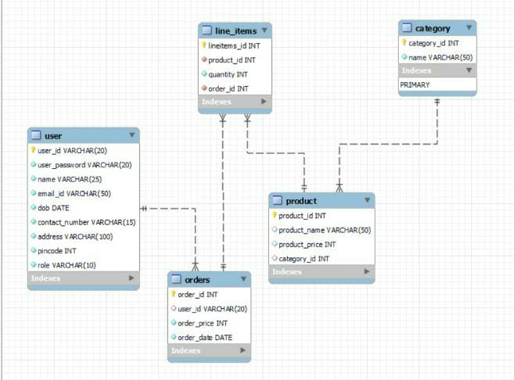

**User Interface:**

1. Upon starting program, User will be presented with Main Menu which looks as below. User can select any of the 3 options and initiate interacting with system. If any other option is entered other 1,2 or 3, user will be prompted again to enter correct option.

------------------------------------------------------------------------------------------------------------------------------

Main Menu

* Register
* Login
* Exit

Enter your choice (1 for Registration, 2 for Login, 3 for Exit):

Upon pressing 1:

Do you want to register as an Admin or a Customer?

_________________________________________________

User will be presented with the option of entering whether he wants to register as a customer user or an admin user.

After typing in either customer or admin, the user will be presented with some questions which he should enter.

Enter the User Id you want to register as:

Enter the password that you want to set:

Enter your e-mail id to receive updates:

Enter your address:

Enter your Date of Birth in the format dd/mm/yyyy

Enter your Phone number:

Enter your pincode:

Thankyou for successfully registering with us!!!!

The main menu will be displayed once again.

Upon pressing 2:

___________________________________________

Enter User ID:

Enter Password:

The user will be asked to type in his login credentials which is the User_id and the password. If incorrect credentials are typed in, the console will leave a message saying that

________________________________________________________________________

“ Incorrect login credentials were typed in, please enter the correct credentials in order to login”.

The main menu will return.

If the correct details are typed in then, a message will be displayed saying

________________________________________________________________________

“User_name details printed !!!!”

If the logged in user is a customer then, as soon as he logins, all the category names available will be displayed.

------------------------------------------------------------------------------------------------------------------------------

Products

(*Note: I have hardcoded the values here, as I have taken only 3 categories)

1. Personal Care
2. Nutrition
3. Health Care

Enter the product category you would like to purchase (For ex: 1: Personal care):

The products present inside the particular category will be displayed.

The customer will be displayed with the following options

1. Place Order
2. Update Order
3. Cancel Order

_________________________________________________________________________________

If the logged in user is an admin then, as soon as he logins, he will get a display with the following options.

1. View all orders list
2. View a specific order based on the order_id entered
3. Place an order
4. Sign Out/ Exit

When 1 is pressed

An admin will be able to see all the order details for every user, who has ordered something.

When 2 is pressed the admin will be asked to type in the user_id for the specific user he wants to look at

Type in the user Id for the user who’s details you want to view:

After typing in the user_id, the admin will be able to look at all the orders of which the user_id has specifically placed.

The admin will then be presented with the option of being able to delete any particular order there by entering the order_id.

_________________________________________________________________________________

When 3 is pressed, the admin will be asked to enter the user_id and password for the user he wants to place an order for.

He can place an order for himself by entering his own credentials, or he can place an order on behalf of a customer by entering his credentials in when asked.

UML Use Case Diagram

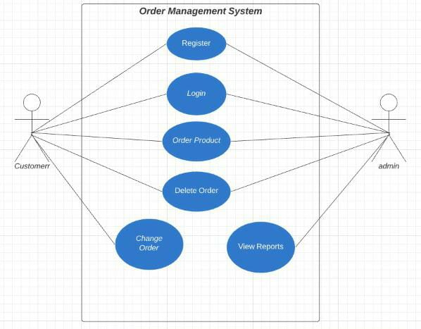

**Functional Testing**

After executing the code from Implementation.main(String[] args)

This should be shown on the screen

Main Menu

________________

• Register

• Login

• Exit

Enter your choice (1 for Registration, 2 for Login, 3 for Exit)

If 1 is pressed this should be the expected result.

Enter the User Id which you want to set:

After entering “tombrady12” as the user ID this should be the expected result:

Enter the password which you want to set:

After entering “tombrady12” this is the expected result:

Enter your Name:

After entering “Tom Brady” this is the expected result:

Enter the email id at which you want to get updates at:

After entering “[tb12@gmail.com](mailto:tb12@gmail.com)” this is the expected result:

Enter your Date of birth:

After entering “03/08/1977” this is the expected result:

Enter your phone number:

After entering “5051233456” this is the expected result:

Enter your address:

After entering “Tampa Bay” this is the expected result:

Enter your zipcode:

After entering “300020” this is the expected result:

What type of role are you registering for: Admin or Customer?

After entering “Admin” this is the expected result:

You have been successfully registered for the website.